


CREDIT RISK ANALYSIS USING SAS ENTERPRISE MINER



Submitted on 3rd December 2014
THE UNIVERSITY OF TEXAS
DALLAS
Under the guidance of:
Dr. Radha Mookerjee
Submitted by:
Group 01

Table of Contents:
- EXECUTIVE SUMMARY
  - DEFINE BUSINESS PROBLEM……………………………………………………………3
  - OBJECTIVE………………………………………………………………………………………3
  - PROJECT GOALS……………………………………………………………………………..3
- DATA DESCRIPTION
2.1 SOURCE AND DESCRIPTION………………………………….…………….……..……3
2.2 TARGET VARIABLE…………………………………………………………………………..3
2.3 NATURE OF TARGET VARIABLE………………………………………………………..4
2.4 DESCRIPTION OF TRAINING AND VALIDATION DATA……………………….4
2.5 DATA PARTITION…………………………………………………………….……………….4
2.6 VARIABLES AND THEIR DESCRIPTION……………………………………...……….5
3. VARIABLE SELECTION
3.1 SELECTION METHOD……………………………………………………………………….9
4. PREPROSESSING TECHNIQUES
4.1 MANUAL OR INTUITIVE METHODS…………………………………………………..9
4.2 VARIABLE CATEGORIZATION…………………………………………………………..10
4.3 TRANSFORM VARIABLES……………………………………………………….………..10
5. SAS ENTERPRISE MINER CLASSIFIERS
5.1 DECISION TREES………………………………………………………………..……………12
5.2 LOGISTIC REGRESSION…………………………………………………..……………….13
5.3 NEURAL NETWORKS……………………………………………………..………………..13
6. MODEL COMPARISON
6.1 ROC CURVE ANALYSIS……………………………………………………….……………13
6.2 ROC CURVE FOR OUR MODEL………………………………………………….…….13
6.3 FIT STATISTICS………………………………………………………………………..………14
6.4 AVERAGE SQUARED ERROR………………………………………………..………….15
6.5 CUMULATIVE LIFT CHART FOR TRAINING DATA……………………………..15
6.6 CUMULATIVE LIFT CHART FOR VALIDATION DATA…………………….…..15
6.7 CHAMPION MODEL……………………………………………………………………….16
6.8 CLASSIFICATION TABLE FOR DECISOIN TREE………………………………….16
6.9 CONFUSION MATRIX…………………………………………………………………….17
7. SCORING
7.1 DESCRIPTION OF SCORING DATA……………………………………….…………18
7.2 READING THE OUTPUT……………………………………………………….………..18
7.3 PREDICTION OF RISKY OR NOT RISKY……………………………......………...20
7.4 PREDICTION OF ACTUAL FICO SCORE………………………………….………..22
8. VALUE TO BUSINESS
GROUP 01
Tamanna Sahoo
Preeta Borkar
Shobhit Dalal
Prashanth Gowda
Rahul Ravesh

- EXECUTIVE SUMMARY

1.1 DEFINE BUSINESS PROBLEM
The business faces a problem in determining whether a customer is risky or not. After we analyze what factors affect the credit score, Bank will be able to identify the risky customers.
1.2 OBJECTIVE
- To build predictive decision models using SAS enterprise miner that will be the best indicator of whether a customer is risky or not based on the FICO score.

- Compare regression analysis, decision tree model and neural network and select the one that predicts accurately based on the input data.

1.3 PROJECT GOALS
- Analyze the factors affecting the credit score
- Data modelling and analyses
- Decide whether a customer is risky or not

- DATA DESCRIPTION

2.1 SOURCE AND DESCRIPTION: The data is a credit line billing testing data from CITI BANK database from their test environment. It gives the information about the business line credit card information. The data set contains customer’s unique id, their monthly credit card bill amount, how many times they have defaulted to pay the bill on time (delinquency), their FICO score based on various attributes, credit limit, utilization of their credit limit, etc.
2.2 TARGET VARIABLE: We have chosen FICO Score/ Credit score (FICO_SCORE_VAL in data set) as the target variable as it will help to determine whether a customer is risky or not. FICO takes credit information and uses it to create scores that will help business to predict behavior, such as how likely someone is to pay their bills on time (or not), or whether they are able to handle a larger credit line. Scores developed by FICO can also be used to forecast which accounts are most likely to end up included in bankruptcy, or which ones are likely to be most profitable.

2.3 NATURE OF TARGET VARIABLE: Fico score ranges from 300 – 850. The business (CITIBANK) has decided FICO score less than 400 to be risky. We have considered the same categorization and considered customers below 400 as risky. Citibank further categorizes the risky customers (FICO score less than 400) into ranges -1 to 5 (-1 being the most risky).

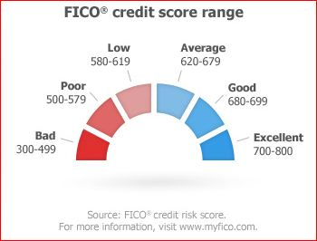

2.4 DESCRIPTION OF TRAINING AND VALIDATION DATA:
Number of customers: 1000
Years for which data has been taken: 2010 – 2013 (4 Years)
Number of records: 42091
Initial number of variables: 50

The initial percentage of risky customers in the data was 39.11% and non-risky customers was 60.89%.

  - DATA PARTITION: 70% of the data is used as training data and 30% of the data is used as validation data

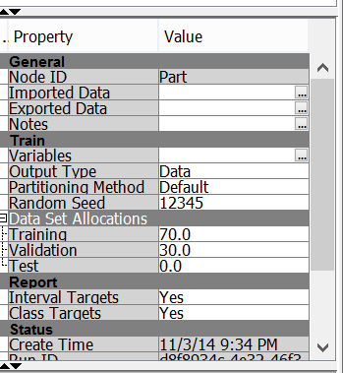

  - VARIABLES AND THEIR DESCRIPTION:
We have included 30 variables as:
# | NAME | ROLE | LEVEL | DESCRIPTION
1. | ACCT_ONLIN_CD | Rejected | Nominal | It indicates the account online access status for the cardholder.  Multi-value attribute with possible values as:  - Blank Not Enrolled  - E Enrolled  - R Re-enrolled
2. | ACCT_ONLIN_CD_BLANK | Rejected | Binary | When ACCT_ONLIN_CD = BLANK then, ACCT_ONLIN_CD_BLANK = 1
3. | ACCT_ONLIN_CD_E | Input | Binary | When ACCT_ONLIN_CD = E then, ACCT_ONLIN_CD_E = 1
4. | ACCT_ONLIN_CD_R | Input | Binary | When ACCT_ONLIN_CD = R then, ACCT_ONLON_CD_R = 1
5. | BANKT_IND | Input | Binary | Bankruptcy-Indicator ::  It identifies accounts that are considered currently bankrupt for a specific billing cycle as defined by CAM-BANKRPT-IND=B.  (BANKT_IND = 0) indicates Non-bankrupt  (BANK_IND = 1) indicates Bankrupt.
6. | BILL_MON_NUM | Rejected | Interval | Bill-Month-Number:  It is the numeric value of the calendar month in which the billing event occurred. For example; if the billing event occurs on May 10; 1996; bill month number = 5. Uses CAM reference table TIME_PER to lookup the billing month number based
7. | BILL_YR_NUM | Rejected | Interval | Bill-Year-Number:  It is the numeric value of the calendar year in which the billing event occurred. For example; if the billing event occurs on May 10; 1996; bill year number = 1996. Uses reference table TIME_PER to lookup the billing year number based on CL_BILL.BILL_DT
8. | BUCKET_CD | Rejected | Interval | Bucket-Code:  It is a unique code that designates the delinquency bucket that the account is in at time of billing.  -If the account is not delinquent the code is 0.  -If the account is GCL the code is 7.  -Otherwise the code matches the delinquency bucket.
9. | BUCKT_1_IND | Input | Binary | Bucket_1_Indicator:  It identifies those accounts in delinquency bucket 1 or A for the current billing cycle
10. | BUCKT_2_IND | Input | Binary | Bucket_2_Indicator:  It identifies those accounts in delinquency bucket 2 or B for the current billing cycle
11. | BUCKT_3_IND | Input | Binary | Bucket_3_Indicator:  It identifies those accounts in delinquency bucket 3 or C for the current billing cycle
12. | BUCKT_4_IND | Input | Binary | Bucket_4_Indicator:  It identifies those accounts in delinquency bucket 4 or D for the current billing cycle
13. | BUCKT_5_IND | Input | Binary | Bucket_5_Indicator:  It identifies those accounts in delinquency bucket 5 or E for the current billing cycle
14. | BUCKT_6_IND | Rejected | Binary | Bucket_6_Indicator:  It identifies those accounts in delinquency bucket 6 or F for the current billing cycle
15. | CLOSE_BAL_AMT | Rejected | Interval | Closing_Balance_Amount:  -It is the total balance for the account at the time of billing.  -The closing balance amount for a cycle becomes the opening balance amount for the next cycle.
16. | CL_TID | ID | Interval | Card_Lineage_Number:  -It is the unique identifier of a single, specific credit line/card lineage extended by Citibank to an individual.  -It will be used to thread together all credit card accounts that logically make up a single card lineage over time.  -CL_TID allows for historical tracking and analysis of one account through lost, stolen, brand conversion, and account consolidation without the security issues of using real account numbers.
17. | DELNQ_STAT_CUR_MONTH | Rejected | Nominal | DELINQUENCY-STATUS-CURRENT-MONTH is the account payment/delinquency status for the current month.
18. | DYNAMIC_CA_LIMIT | Input | Interval | DYNAMIC-CASH-ADVANCE-LIMIT is the amount available as the maximum cash advance taking into consideration any cushions as noted during the account history recorded at billing date
19. | DYNAMIC_CREDIT_LIMIT | Input | Interval | DYNAMIC-CREDIT-LIMIT is the dollar amount; taking into consideration any cushions; that is the maximum that may be charged to the account
20. | FICO_SCORE_VAL | Target | Binary | This is the bankcard industry option score.
21. | GCL_IND | Input | Binary | Gross_Credit_Loss_Indicator:  -It is a binary indicator that identifies those accounts that should be included in the Gross Credit Loss calculations.  -These are accounts that are either bankrupt or contractually written-off.
22. | HIGH_BILL_BAL_AMT | Input | Interval | Highest_Balance_Billed_Amount:  It is a numeric value equal to the highest balance ever billed. This balance includes cash advance. Note: the HIGH_BILL_BAL_DT does not correspond with this balance.
23. | LAST_PAY_AMT | Input | Interval | Last_Payment_Amount:  It is the dollar amount of the last payment posted against the account
24. | LIFE_BAD_CHK_CT | Input | Interval | Lifetime_Bad_Check_Count:  It is the number of /count of bad checks written to Citibank as payment on balance over the lifetime of the account as recorded in the account history at calendar month end date.
25. | LIFE_CA_CT | Input | Interval | Lifetime_Cash_Adavances_Count:  It is the number of / or count of cash advances issued over the lifetime of the account as recorded in the account history at calendar month end date.
26. | LIFE_PURCH_AMT | Input | Interval | Lifetime_Purchase_Amount:  It is the dollar amount of purchases accumulated over the lifetime of the account as recorded in the account history at calendar month end date.
27. | LIFE_PURCH_CT | Input | Interval | Lifetime_Purchase_Count:  It is the number of /count of purchases made over the lifetime of the account as recorded in the account history at calendar month end date.
28. | MON_ON_BOOK_CT | Input | Interval | Months_On_Book_Count:  It is a count of how many months have elapsed since the card lineage was established.  In other words; it is the number of months elapsed since the first account in the card lineage was originally opened.
29. | OPEN_BAL_AMT | Input | Interval | Open_Balance_Amount:  It is the opening balance at the start of the current billing cycle for a particular account.  The opening balance amount is the same as the closing balance amount from the previous cycle.  If there is no previous cycle; the opening balance amount is 0.
30. | UTIL_RATE | Input | Interval | Utilization_Rate:  It is the percentage of the Total Credit Limit that a particular card lineage is utilizing.  The utilization rate is calculated by dividing the account balance by the account credit limit.

- VARIABLE SELECTION

3.1 SELECTION METHOD:
Since our main is to predict the FICO score and determine if the customer is risky or not, our target Variable is FICO_SCORE_VAL
Initial number of predictor variables: 50

- PREPROCESSING TECHNIQUES

To reduce the curse of dimensionality, we have employed the following preprocessing techniques:
- Manual or intuitive methods
- Variable Categorization
- Transform Variables

4.1 MANUAL OR INTUITIVE METHODS:
All variables were checked for any sort of preliminary data inconsistency.

- The dataset had many columns with missing values. For example, personal information like SSN Number, Salary was not disclosed to us. Besides this, there were few columns for which data was not recorded to certain years. Such columns were deleted.

- Some columns were discarded as they were irrelevant to predict FICO score. This was discussed with the business expert from Citi Bank. E.g.: Interest Rebate Amount (INT_REBATE_AMT) or Interest Credit Amount (CYCLE_INTEREST_CR_AMT) did not play any role in FICO score prediction.

- Variables with same values for all rows or almost all rows were discarded. E.g. : Period Number(PER_NUM), Retention-offer-group (RETN_OFFER_GRP_ID)

- Converted nominal data into binary values by creating columns for each value and rejecting one of the column for avoiding multicollinearity in SAS miner.

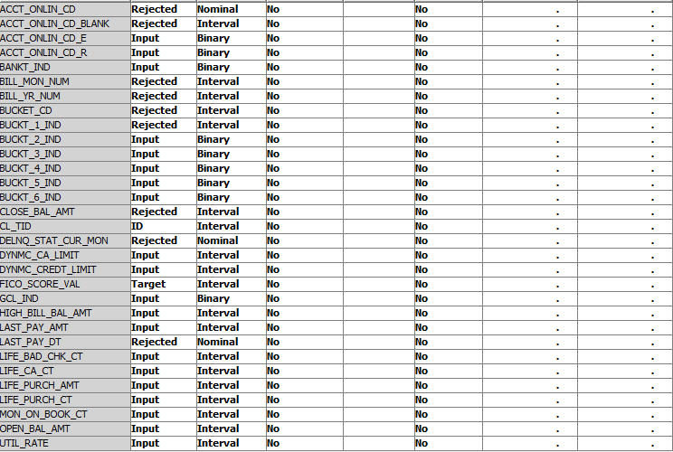

4.2 VARIABLE CATEGORIZATION:
All the derived variables like Interest Rate, Interest Paid were discarded.

4.3 TRANSFORM VARIABLES:
Our target variable (FICO score) had interval values. However our expected result was 1 – Customer is Risky or 0 – Customer is not risky. Hence, we converted it to binary by using the Transform Variable node.
The formula under train properties has been given as:
FICO score<400 - customer is risky (1)
FICO score>400 - customer is not risky (0)

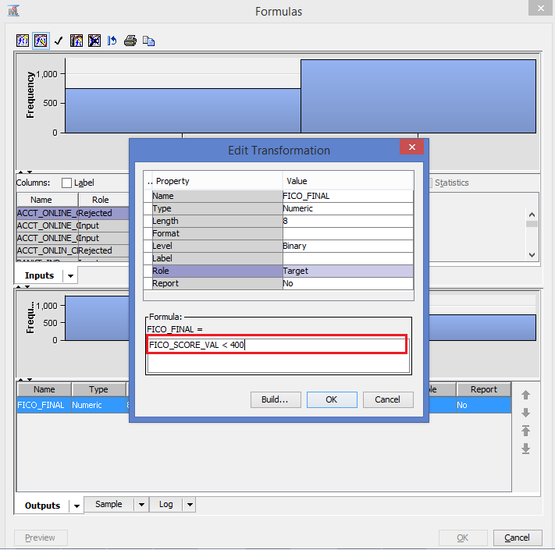

SAS ENTERPRISE MINER MODEL

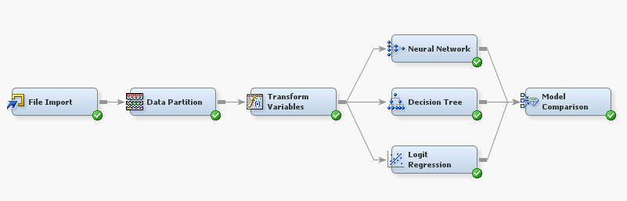

- SAS ENTERPRISE MINER CLASSIFIERS
We have employed the following Classification techniques for predictive analysis:
- Decision Trees
- Logistic Regression
- Neural Networks

  - DECISION TREE: The significance level has been set to 0.05.
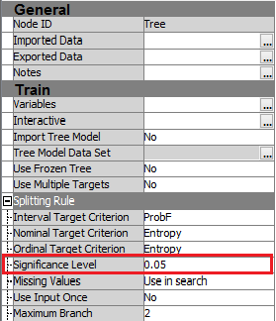

  - REGRESSION: The model selection under train properties has been set to stepwise.
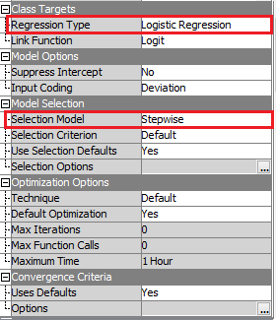

5.3 NEURAL NETWORK: Default settings for neural network
6. MODEL COMPARISON
The Model Comparison gives out the best model for the analysis:
  - ROC CURVE ANALYSIS:
In order to compare several competing models rather than estimate their performance independently we use a technique called the Receiver Operating Characteristic (ROC) Curve.
A ROC curve characterizes the relation between positive hits and false alarms and it provides a graphical visualization to analyze the relationship between the true positive rate and the true negative rate. The performance of each classiﬁer is represented as a point on the curve.
The optimal point in the graph is the top-left corner, i.e., all positive instances are classified correctly and no negative instances are misclassified as positive. The diagonal line on the graph represents the scenario of randomly guessing the class, and so it represents the minimum baseline for all classifiers.

  - ROC CURVE FOR OUR MODEL:

As we can see in the above diagram, all the classification techniques are doing fairly good. Since we are looking for the best classifier, Decision Tree turns out to be the Champion since it is farthest away from the Baseline.
  - FIT STATISTICS:

The misclassification rate calculates the proportion of an observation being allocated to the incorrect group.
As we can see in the above Fit statistics, out of the three models, i.e. Decision Tree, Neural Network and Logit Regression, the model with the least Misclassification Rate for Training and Validation data is Decision Trees.
  - AVERAGE SQUARED ERROR:
The Average squared error of an estimator measures the average of the squares of the "errors", that is, the difference between the estimator and what is estimated.
The best model is the one with least Average Squared Error, and once again Decision Tree has the least Average Squared Error for both Training and Validation Data.

  - CUMULATIVE LIFT CHART FOR TRAINING DATA:

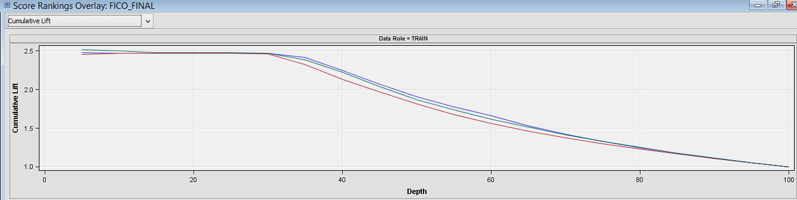

  - CUMULATIVE LIFT CHART FOR VALIDATION DATA:

  - CHAMPION MODEL:
The cumulative lift chart visually shows the advantage of using a predictive model to choose who are going to be Risky Customers by answering the question of how much more likely the customer is Risky than if we chose the random sample of customers.
The x-axis shows the percentile and the y-axis shows lift. The default (No Model) is a horizontal line intersecting the y-axis at 1. If we contact a random percentage of the population using no model, we should get 35% of the at-risk customers by default; this is what we mean by no lift (or lift=1). The chart above shows that using the given model we should be able to capture majority of the risky customers if we contact the customers with risk scores in the top 10 percentile. That is more than many as if we use no model, so that is our “lift” over the baseline.
From the above graph, the Cumulative Lift curve for Decision tree is farthest from the default (No Model) horizontal line.
Considering all the Model Comparison statistics, the best model for the predictive analysis turns out is the Decision Tree.

  - CLASSIFICATION TABLE FOR DECISION TREE:

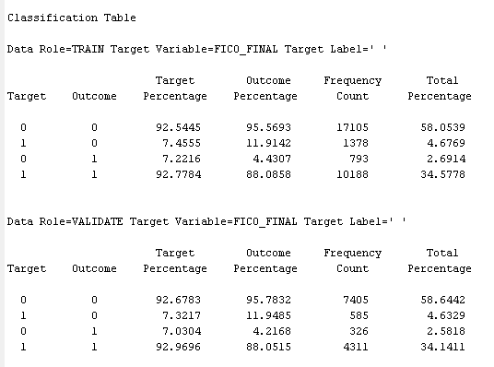

  - CONFUSION MATRIX/CLASSIFICATION TABLE:

Training Data:
 | Predicted
Actual |  | 0(Negative) | 1(Positive)
Actual | 0(Negative) | 58.0539 | 2.6914
Actual | 1(Positive) | 4.6769 | 34.5778

Accuracy = Number of Correct predictions/Total Number of predictions = 92.62%
Error rate = Number of Wrong predictions/Total Number of predictions = 7.38%

Validation Data:
 | Predicted
Actual |  | 0(Negative) | 1(Positive)
Actual | 0(Negative) | 58.6442 | 2.5818
Actual | 1(Positive) | 4.6329 | 34.1411

Accuracy = Number of Correct predictions/Total Number of predictions = 92.78%
Error rate = Number of Wrong predictions/Total Number of predictions = 7.22%

- SCORING
Score refers to a predicted value or class. "Scoring new data" means to use a model developed with training data to predict output values in new data. The score function is used to judge the quality of the fitted models or patterns.

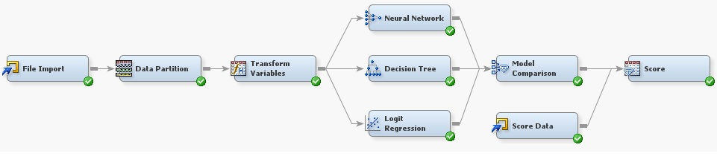
  - DESCRIPTION OF SCORING DATA:
Number of customers: 100
Years for which data has been taken: 2010 – 2013 (4 Years)
Number of records: 4128

  - READING THE OUTPUT OF THE SCORING FUNCTION:

Percentages of 1’s and 0’s in training data

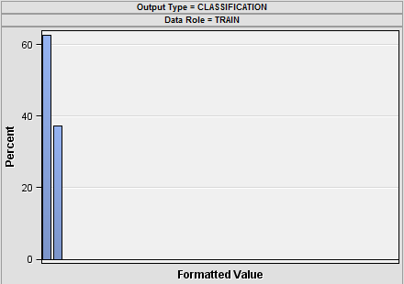

Training data output shows that 62.73% of the total values are 0 and 37.27% as 1. It represents that 62.73% of the customers are not risky, while 37.27% of the customers are risky.

Percentages of 1’s and 0’s in validation data

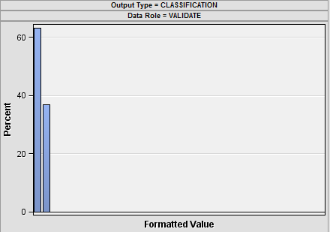

Validation data output shows that 63.28% of the total values are 0 and 36.72% as 1. It represents that 63.28% of the customers are not risky, while 36.72% of the customers are risky.

Percentages of 1’s and 0’s in scoring data

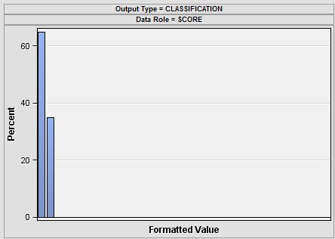

Validation data output shows that 65.04% of the total values are 0 and 34.96% as 1. It represents that 65.04% of the customers are not risky, while 34.96% of the customers are risky.

  - PREDICTION OF RISKY (1) OR NOT RISKY (0) CUSTOMERS: Since, the model is not 100% accurate, some of the values are wrongly predicted.

Example 1: In observation number 4 and 22, although they have a FICO score of 718 and 778 respectively but they have been misclassified as risky customers.

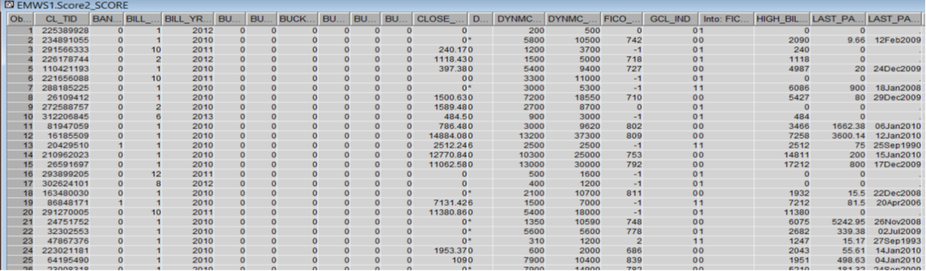

Example 2: In this it is seen that the customer with customer id 132948157 has a FICO score of 999 but still has been classified as a risky customer. Analyzing the data and taking conventions for FICO score followed by CITI Bank, it was found that FICO score 999 does not mean a good FICO score. CITI Bank marks the FICO score of a customer whose account has been deactivated due to bankruptcy as 999. Hence the model classifies such customers risky.
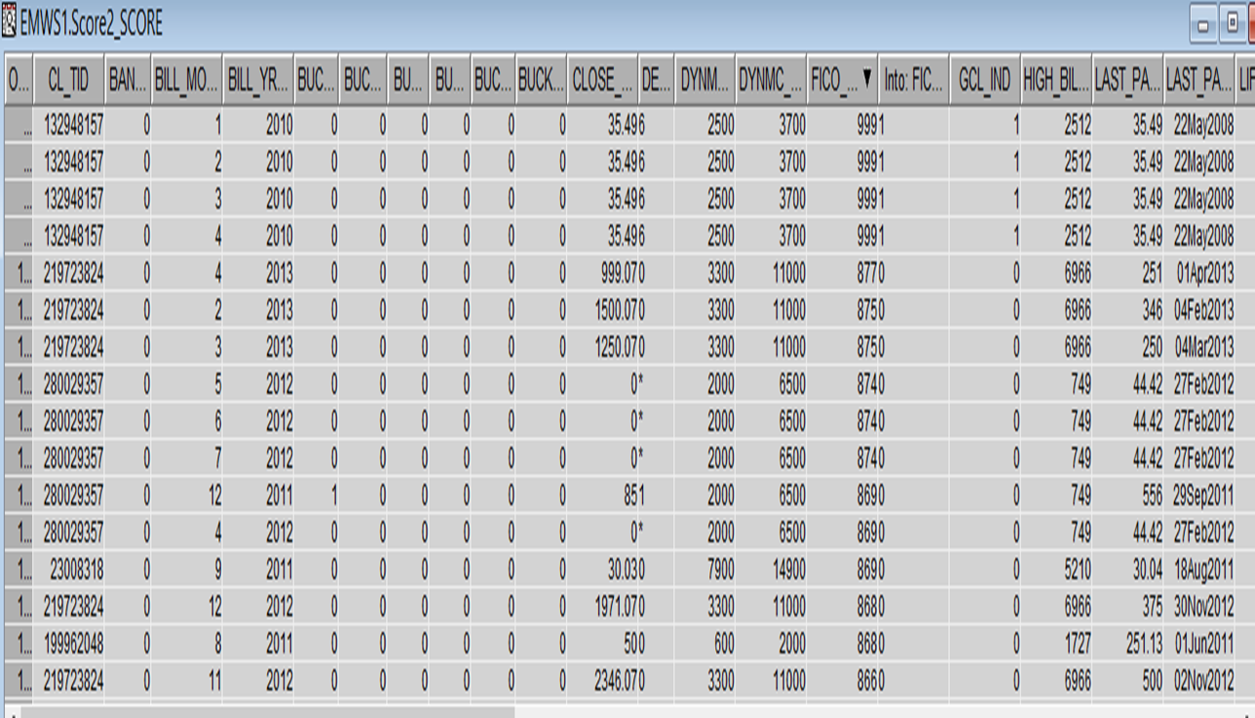

Example 3: Few of the risky customers (having FICO score -1) have been classified by the model as not risky. On analyzing we found that the customer was paying the bills on time but in some month he had utilized more than 100% of his credit limit.

  - PREDICTION OF ACTUAL FICO SCORE:

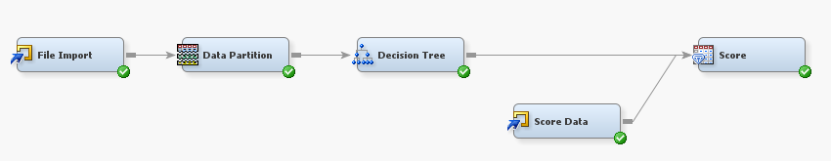

Additionally, we have designed a model that will predict the actual FICO score of the customer. Below is the output for the same where the model has predicted the FICO score close to the original FICO score of the scoring data.

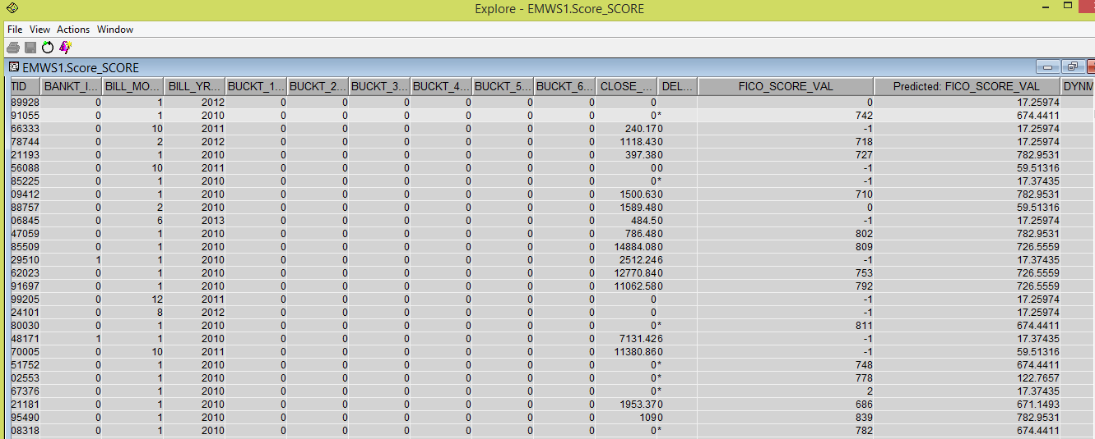

- VALUE TO BUSINESS
- CITIBANK is able to predict the risky customers by using our model
- They can use this model to take decision whether a customer’s credit limit should be increased or decreased based on his/her credit score

------------------------------------------------------End of Report------------------------------------------------------

